VISVESVARAYA TECHNOLOGICAL UNIVERSITY JNANA SANGAMA, BELAGAVI



# INTERNSHIP REPORT

## 220/66/11 KV Substation, Vajamangala 66/11 KV GIS Substation, Kalamandir 66/11 KV Substation, R K Nagara

***Submitted in partial fulfillment for the award of the degree of***

## BACHELOR OF ENGINEERING

### Submitted By

**AKHILA S M (4GW18EE002) BHAVANA V M (4GW18EC012) CHAITRA V (4GW18EE007)**

### SHEETAL N (4GW18EE039) SOUNDARYA M K (4GW18EE041)



**GSSS INSTITUTE OF ENGINEERING & TECHNOLOGY FOR WOMEN**

**Affiliated To Visvesvaraya Technological University, Belagavi Approved By All India Council for Technical Education, New Delhi**

**K.R.S. Road Metagalli, Mysuru – 570 016 Accredited with Grade ‘A’ by NAAC**

### CONTENTS

**LIST OF FIGURES ..................................................................................................................**

### LIST OF TABLES ....................................................................................................................

CHAPTER 1

KPTCL 1-4

* 1. ABOUT 1
  2. EVOLUTION OF ELECTRICITY IN KARNATAKA 1
  3. FUNCTION OF THE ORGANIZATION 2
  4. EXISTING INFRASTRUCTURE AND PERFORMANCE 3

CHAPTER 2

BACKGROUND 4-7

* 1. NEED OF ELECTRICITY 4
  2. A BRIEF NOTE ON ELECTRIC POWER GENERATION 5

CHAPTER 3

TRANSMISSION AND DISTRIBUTION 8-13

* 1. INTRODUCTION 9
  2. COMPONENTS OF DISTRIBUTION 13
  3. TYPES OF TRANSMISSION 16
  4. TRANSMISSION LINES

CHAPTER 4

SUBSTATION 17-22

* 1. ELECTRICAL SUBSTATION 17
  2. ELEMENTS OF A SUBSTATION 18
  3. TRANSMISSION SUBSTATION 18
  4. DISTRIBUTION SUBSSTATION 19
  5. COLLECTOR SUBSTATION 19
  6. AC SUBSTATION 20
  7. SWITCHING FUNCTION 20
  8. CORONA EFFECT 21
  9. SKIN EFFECT 21
  10. FERRANTI EFFECT 22

CHAPTER 5

COMPONENTS OF AN ELECTRICAL SUBSTATION 23-29

* 1. LIGHTNING ARRESTERS 23
  2. WAVE TRAPPER 23
  3. CURRENT TRANSFORMER 24
  4. GROUP OPERATING SYSYTEM 24
  5. CIRCUIT BREAKER 24
  6. POTENTIAL TRANSFORMER 25
  7. BUS BAR 25
  8. BATTERIES 25
  9. SWITCH YARD 26
  10. RELAYS 26
  11. CAPACITOR BANK 26
  12. TRANSFORMER 26

CHAPTER 6

TRANSFORMER LINE 28-34

* 1. INTRODUCTION 28
  2. BASIC PRINCIPLE 29
  3. DIFFERENT PARTS OF A TRANSFORMER 29

CHAPTER 7

PROTECTIVE EARTHING AND TRANSFORMER PROTECTION 35-38

* 1. PROTECTIVE EARTHING 35
  2. TRANSFORMER PROTCTION 35

CHAPTER 8

### PROTECTIVERELAYS 39-41

CHAPTER 9

### 220/66/11 KV SUBSTATION 42-45

CHAPTER 10

### 66/11 KV GIS SUBSTATION 46-50

CHAPTER 11

### 66/11 KV SUBSTATION 51-53

CHAPTER 12

**CONCLUSION 54**

# CHAPTER 1

**KARNATAKA POWER TRANSMISSION CORPORATION LIMITED**

## ABOUT:

Karnataka Power Transmission Corporation Limited is a registered company under the companies act, 1956. Was incorporated on 28-07-1999. And is a company wholly owned by the government of Karnataka with an authorized share capital of Rs.1000 crores. KPTCL was formed on by Carving out the transmission and distribution functions of the erstwhile Karnataka electricity board.

KPTCL is headed by a Chairman and Managing Director at the Corporate Office. He is assisted by 4 functional directors. The board of KPTCL consists of a maximum of 12 directors.

Karnataka Power Transmission Corporation Limited is mainly vested with the functions of transmission and distribution of power in the entire state of Karnataka. It operates under a license issued by Karnataka Electricity Regulatory Commission. KPTCL purchases power from Karnataka Power Corporation Limited, which generates and operates major power generating projects in the state consisting of Hydel, Thermal and other source. KPTCL purchases power from KPC at the rate fixed by state Government from time to time.

KPTCL also purchases power from Central Government owned generating stations like National Thermal Power Corporation, Neyvelli Lignite Corporation and the Automic Power Stations at Kalpakkam and Kaiga. The approximate share of power from these generating stations is around 16%. KPTCL serves nearly 109 lakhs consumers of different categories spread all over the state covering an area of 1.92 lakh square Kilometers. To transmit and distribute power in the state it operates nearly 684 sub stations, 28000ms, of transmission lines with voltages of 33KV and above nearly 130000 Kms of 11KV lines, 150000 distribution transformers and 357000 Kms of LT lines.

## EVOLUTION OF ELECTRICITY IN KARNATAKA:

The history of the phenomenal development of the old Mysore state was synonymous to the working of a few of its outstanding rulers and administrators. The principal persons who have contributed to the prosperity of Mysore state through their farsighted vision were his Highness the Maharaja Sri Krishna raja Wadiyer and famous diwans Sir K.Sheshadri Iyer, Sir M.Visvesvaraiah and Sir Mirza Ismail. Among the many measures of prosperity contributed by them the outstanding contribution was initiatives of prosperity contributed by them the outstanding contribution was initiatives taken for harnessing electric power. The history of power development in Mysore state makes an interesting reading. In fact, the first light was lit on our soil before Thomas Alva Edison invented electric bulb during May 1878, on the occasion of marriage of his highness chamarajendra wadiyar. This system was the source of light for the place up to 26th Sept.1908, when power supply from Shivanasamudra reached the Mysore place.

The history of the phenomenal development of the old Mysore state was synonymous to the working of a few of its outstanding rulers and administrators. The principal persons who have contributed to the prosperity of Mysore state through their farsighted vision were his Highness the Maharaja Sri Krishna raja Wadiyer and famous diwans Sir K.Sheshadri Iyer, Sir M.Visvesvaraiah and Sir Mirza Ismail.

Among the many measures of prosperity contributed by them the outstanding contribution was initiatives of prosperity contributed by them the outstanding contribution was initiatives taken for harnessing electric power. The history of power development in Mysore state makes an interesting reading. In fact, the first light was lit on our soil before Thomas Alva Edison invented electric bulb during May 1878, on the occasion of marriage of his highness chamarajendra wadiyar. This system was the source of light for the place up to 26th Sept.1908, when power supply from Shivanasamudra reached the Mysore place.

## FUNCTION OF THE ORGANIZATION:

Karnataka Power transmission Corporation Limited is mainly vested with the functions of transmission of power in the entire at competitive rate by adopting best technical, high order maintenance and best customer service to its customers. KPTCL purchases power from

Karnataka Power Corporation Limited (KPTCL) which generated and operates major power generating projects of the state consisting of Hydel and Thermal an other sources. KPTCL purchases power from Karnataka Power Corporation Limited (KPTCL) at the rate fixed by the Government from time to time. The two power houses one on the left bank of Tungabhadra board, which is represented by the state governments of Andhrapradesh, Karnataka and Government of India and 20% of the energy generated by the above generating stations is the share by the above stations is the share of Karnataka Power Transmission Corporation Limited. Of central M.P. BIRLA INSTITUTE OF MANAGEMENT 16 allocation of power out of NTPC, NILL and MAPP generating stations at Ramagundam, Neyveli, and Chennai respectively, the share of KPTCL is 16%.

Only one Rural Electric Co-operative Society viz., the Hukkeri Electric Cooperative Society Limited, at Hukkeri is functioning in Karnataka (Hukkeri Taluk Belgaum District) which purchases bulk power from KPTCL / VVNL and redistributes it to the consumer within the taluk.

## EXISTING INFRASTRUCTURE AND PERFORMANCE

In June 2002, KPTCL emerged as the sole transmission company in Karnataka. It is responsible for power transmission in the state, as well as the construction and maintenance of 33 kV and above stations and lines. As of March 2018, the state-owned company owns 1,514 substations – five substations at the 400 kV level, 101 at 220 kV, 413 at 110 kV, 637 at 66 kV and 358 at 33 kV. KPTCL’s network comprises 36,124 ckt. km of transmission lines at the 66 kV and above voltage levels. Its network increased by 3 per cent from 35,119 ckt. km in the previous year. Of the current line length, about 31 per cent is at the 220 kV level, 30 per cent at 66 kV, 29 per cent at 110 kV and 10 per cent is at the 400 kV level.

# CHAPTER 2

# BACKGROUND

## NEED OF ELECTRICITY

Electricity is one of the greatest technological innovations of mankind. It has now become a part of our daily life and one cannot think of a world without electricity. Electricity is now an important part of homes and industries. Almost whole the devices at homes, businesses and industries are running because of electricity. The primary use of electricity depends on the place where it is used and the nature of the facility.For example, importance of electricity in our daily life:

At home: Electricity is important to run your appliances at home efficiently. Ex: Lighting, Fan, TV

In travelling: As electricity is an important part of our daily lives so is the travelling. Today a vast number of travelling medium like the electric train, aeroplanes, electrical cars, etc.

In medical facility: The medical sector is considering the place where you find continues flow of electricity 24*7*365. Ex: X-Ray machines, ECG, etc.

## A BRIEF NOTE ON ELECTRIC POWER GENERATION

The electric power is generated in different form like hydroelectric power plant, thermal power plant, nuclear power plant, and solar power plant.

### HISTORY

The fundamental principles of electricity generation were discovered in the 1820s and early 1830s by British scientist Michael Faraday. His method, still used today, is for electricity to be generated by the moment of loop of wire, or disc of copper between the poles of the magnet.In 1870 commercial electricity production started with the coupling of the dynamo to the hydraulic turbine. In 1870, the mechanical production of electric power began the second industrial revolution and created inventions using the energy, whose major contributors were Thomas Alva

Edison and Nikola Tesla. The first hydroelectric installation in India was installed near a tea estate at Sidrapong for the Darjeeling Municipality in 1897. Shivanasamudra is a small city in the Mandya District of the state of Karnataka, India. It is situated on the bank of the river Kaveri and the location of one of the first hydroelectric power station in Asia, which was setup in 1902. The project was designed by Diwan Sheshadri lyer. The first hydroelectric power station became operational on June 30, 1902 and then resident General of Mysore state, Donald Robertson launched the 700KW hydroelectric power generation station. Electric energy was transmitted to the Kolar gold fields from the new project.

The first electric street light in Asia was lit on 5 August 1905 in KR Market, Bengaluru. In the year September 1908 the world famous Mysore Palace was illuminated. To meet the increasing demand for power, the Shimsha generating station, with an installed capacity of 17.2MW, was commissioned in the year 1940.

### WAYS OF GENERATING POWER

**COAL POWER GENERATION**: Steam coal, also known as thermal coal, is used in power station to generate electricity, Coal is first milled to a fine powder, which increases the surface area and allows it to burn more quickly. In these pulverized coal combustion (PCC) systems, the powdered coal is blown into the combustion chamber of a boiler where it is burnt at high temperature. The hot gases and heat energy produced converts water-in tubes lining the boiler- into steam.

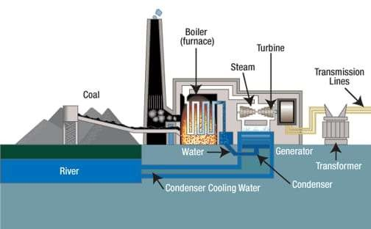

FIGURE 2.1: Coal Power Generation

**HYDRO-POWER GENERATION**: Hydro power is generated by using electricity generators to extract energy from moving water. Historically people used the power of rivers for agriculture and wheat grinding. Today, rivers and streams are re-directed through hydro generators to produce energy, although there are pros and cons as far as local eco-systems are concerned.

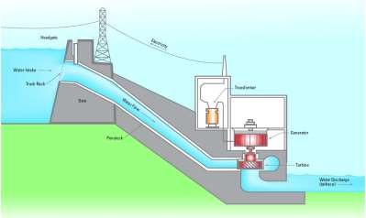

FIGURE 2.2: Hydro Power Generation

**NUCLEAR POWER GENERATION**: It is a thermal power station in which the heat source is a nuclear reactor. As it is typical of thermal power station, heat is used to generate steam that drives a steam turbine connected to a generator that produces electricity. Nuclear plants are usually considered to be base load stations since fuel is a small part of the cost of production and because they cannot be easily or quickly dispatched.

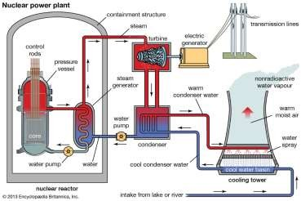

FIGURE 2.3: Nuclear Power Generation

**SOLAR POWER GENERATION**: Solar power is produced by collecting sunlight and converting it into electricity. This is done by using solar panels, which are large flat panels made up of many individual solar cells. It is most often used in remote locations, although it is becoming more popular in urban areas as well.

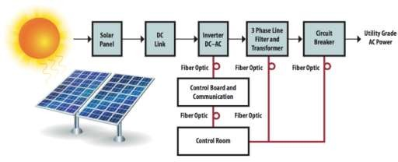

FIGURE 2.4 : Solar Power Generation

# CHAPTER 3

# TRANSMISSION AND DISTRIBUTION

## INTRODUCTION:

The energy can neither be created or destroyed but can be converted from one form to another. The generation of an electrical energy is nothing but the conversion of various other forms of energy into an electrical energy The various energy source which are used to generate an electrical energy on the large wale are seams obtained by buring coal oil natural gas, water stored in dam, diesel oil, nuclear power and other nonconventional many sources. The electrical power generated in bulk the generating stations which are also called power stations. Depending upon the source of energy used these stations are called thermal power station, hydroelectric power station, diesel power station, nuclear power station etc. This generated electrical energy is demanded by the consumers. Hence the generated electrical power is to be supplied to the consumers. Generally the power stations are located too far away from the town and cities where electrical energy is demanded. Hence there exists a large network of conductors between the power stations and the consumers. This network is broadly classified into two parts Transmission and Distribution. The flow of electrical power from the generating station to the consumer is called an electrical power system or electrical supply system. It consists of the following important components :

* + 1. Generating station
    2. Transmission network
    3. Distribution network.

All these important networks are connected with the help of conductors and various steps up and step down transformers. A typical transmission and distribution scheme is shown in fig. A scheme shows a generating station which is located too far away from cities and towns. It is generating an electrical power at 11 kV. It is required to increase this level for the transmission purpose. Hence a step up transformer is used which steps up the voltage level to 220 kV. This level may be 132 kV, 220 kV or more as per the requirement.

Then with the help of transmission lines and the towers, the power is transmitted at very long distances. Design of the transmission lines is based on the factors like transmission voltage levels, constants like resistance, reactance of the lines, line performance, interference with the neighbouring circuits etc. Its mechanical features are strength of the supports, sag calculations, tension etc. Transmission of power by the overhead lines is very much cheaper. Similarly the repairs also can be carried out comparatively more easily. The transmission is generally along with additional lines in parallel, these lines are called

duplicate lines. Thus two sets of three phase lines work in parallel. This ensures the continuity during maintenance and also can be used to satisfy future demand. The power is then transmitted to the receiving station via step down transformer. This transformer is 220/33 kV or 220/22 kV transformer. The power is then transmitted to the substations. A substation consists of a step down transformer of rating 33 kV to 6.6 kV or 3.3 kV. The transfer of power from receiving station to the substation is with the help of conductors called feeders. This is called secondary transmission.

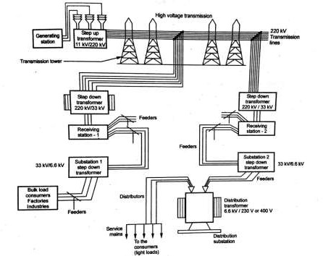

FIGURE 3.1: Schematic representation of a typical transmission distribution scheme

From the substations, power is distributed to the local distribution centers with the help of distributors. Sometimes for bulk loads like factories and industries, the distributors transfer power directly. For the light loads, there are distribution centers consisting of distribution transformers which step down the voltage level to 230 V or 400 V. This is called primary distribution. In the crowded areas like cities, overhead system of bare conductors is not practicable. In such cases insulated conductors are used in the form of underground cables, to give supply to the consumers. These cables are called service mains. This is called secondary distribution.

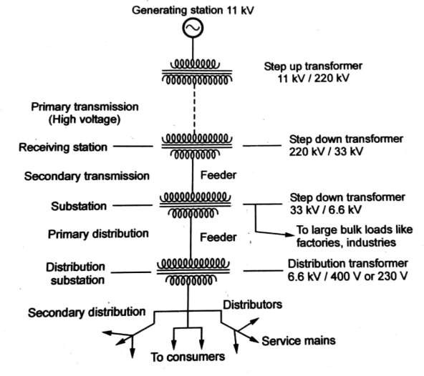

FIGURE 3.2: Line Diagram of a Typical Transmission Distribution Scheme

This is the complete flow of an electrical power from the generating station to the consumer premises the line diagram of such a typical scheme of transmission and distribution and discuss the various components and voltage levels at the various stages in detail the figure shows the line diagram of a typical transmission and distribution scheme. At generating station, an electrical power is generated with the help of three phase alternators running in parallel. In the scheme shown, the voltage level is 11 kV but the voltage level may be 6.6 kV, 22 kV or 33 kV depending upon the capacity of the generating station. After the generating station, actual transmission and distribution starts. The overall scheme can be divided into four sections which are

### PRIMARY TRANSMISSION

It is basically with the help of overhead transmission lines. For the economic aspects, the voltage level is increased to 132 kV, 220 kV or more, with the help of step up transformer. Hence this transmission is also called high voltage transmission. The primary transmission uses 3 phase 3 wire system.

### SECONDARY TRANSMISSION

The primary transmission line continues via transmission towers till the receiving stations. At the receiving stations, the voltage level is reduced to 22 kV or 33 kV using the step down transformer. There can be more than one receiving stations. Then at reduced voltage level of 22 kV or 33 kV, the power is then transmitted to various substations using overhead 3 phase 3 wire system. This is secondary transmission. The conductors used for the secondary transmission are called feeders.

### PRIMARY DISTRIBUTION

At the substation the voltage level is reduced to 6.6 kV, 3.3 kV or 11 kV with the help of step down transformers. It uses three phase three wire underground system. And the power is further transmitted to the local distribution centers. This is primary distribution, also called high voltage distribution. For the large consumers like factories and industries, the power is directly transmitted to such loads from a substation. Such big loads have their own substations.

### SECONDARY DISTRIBUTION

At the local distribution centers, there are step down distribution transformers. The voltage level of 6.6 kV, 11 kV is further reduced to 400 V using distribution transformers. Sometimes it may be reduced to 230 V. The power is then transmitted using distributors and service mains to the consumers. This is secondary distribution, also called low voltage distribution. This uses 3 phase 4 wire system. The voltage between any two lines is 400 V while the voltage between any of the three lines and a neutral is 230 V. The single phase lighting loads are supplied using a line and neutral while loads like motors are supplied using three phase lines.

## COMPONENTS OF DISTRIBUTION

The distribution scheme consists of following important components:

### SUBSTATION

Transmission lines bring the power up to the substations at a voltage level of 22 kV or 33 kV. At the substation the level is reduced to 3.3 kV or 6.6 kV. Then using feeders, the power is given to local distribution centers.

### LOCAL DISTRIBUTION STATION

It consists of distribution transformer which steps down the voltage level from 3.3 kV, 6.6 kV to 400 V or 230 V. Then it is distributed further using distributors. This is also called distribution substation.

### FEEDERS

These are the conductors which are of large current carrying capacity. The feeders connect the substation to the area where power is to be finally distributed to the consumers. The feeders current always remains constant. The voltage drop along the feeder is compensated by compounding the generators.

* + 1. **DISTRIBUTORS**These are the conductors used to transfer power from distribution center to the consumers. From the distributors, the tappings are taken for the supply to the consumers. The voltage drop along the distributors.

### SERVICE MAINS

These are the small cables between the distributors and the actual consumer premises.

## TYPES OF TRANSMISSION:

General two types of systems are used for the transmission:

### OVERHEAD SYSTEM

In this system, the transmission of electrical power is by using overhead transmission lines over long distances. In such system, the appropriate spacing is provided between the conductors, at the supports as well as at the intermediate points. This spacing provides insulation which avoids an electric discharge to occur between the conductors The transmission by overhead system is much cheaper than the underground system The overhead transmission lines are subjected to the faults occurring due to lightening, short circuits, breakage of line etc. but overhead lines can be easily repaired compared to underground system. It is also true that though such faults are rare, if occurred very difficult to find exact point of fault as transmission lines are very long. In the overhead system, the insulation must be provided between the conductor and supporting structure.

### UNDERGROUND SYSTEM

The cables are generally preferred in underground system. All the conductors must be insulated from each other in the underground system. As voltage level is high, insulation required is more. Hence due to insulation difficulties, the voltage level used underground system is below 66 kV while the voltage level used in overhead transmission lines can be as high as 400 kV. The maintenance cost of the system is les compared to overhead system. In crowded areas, overhead system using bare conductors is not practicable where underground system using cables preferred the line surges are suppressed by using the cables hence cable must be used for the last part of the connection which can save transformers and generators from the damage due to line surges.

## TRANSMISSION LINES

Transmission consists of two divisions namely,

* Transmission line.
* 2. Substation (receiving sending)

### 3.4.1 TRANSMISSION LINES

**TOWERS:** According to different considerations, there are different types of transmission towers. The transmission line goes as per available corridors. Due to unavailability of shortest distance straight comdor transmission line has to deviate from its straight way when obstruction comes. In total length of a long transmission line there may be several deviation points. According to the angle of deviation there are four types of transmission tower,

1. A type tower angle of deviation Do to 2o.
2. B-type tower - angle of deviation 20 to 150.
3. C-type tower - angle of deviation 150 to 300.
4. D-type tower - angle of deviation 300 to 600.

As per the force applied by the conductor on the cross arms, the transmission towers can be categorized another way-

1. Tangent suspension tower and it is generally A-type tower
2. Angle tower or tension tower or sometime it is called section tower. All B, C and D types of transformer towers come under this category.

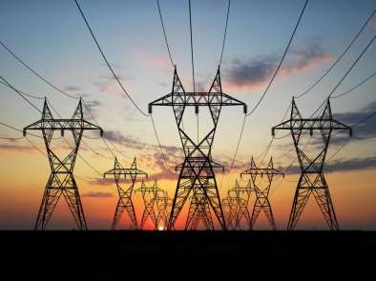

### INSULATOR:

In order to prevent the flow of current from support the transmission lines or distribution lines are all secured to the supporting towers or poles with the help of insulators. Thus the insulators play an important part in the successful operation the lines. The chief operation or requirements for the insulators are:

* + They must be mechanically very strong.
  + Their dielectric strength must be very high.
  + They must be free from the internal impurities.
  + They must provide very high insulation resistance to the leakage currents.
  + They should not be porous.
  + They must be imperious to the entrance of gases or liquids.
  + They should not be affected with change in temperature.
  + They must have high ratio of puncture strength of flesh over voltage.

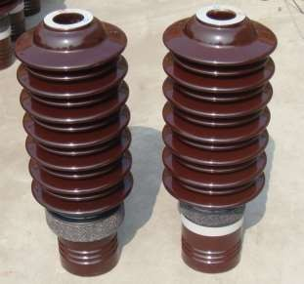

FIGURE 3.4 INSULATORS

**CONDUCTORS:** Conductors are the materials which permit flow of electrons through it. The best conductors are copper and aluminum etc. The conductors are utilized for transmission of energy from place to place over substations.

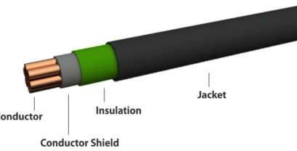

FIGURE 3.4 CONDUCTORS

# CHAPTER 4

# SUBSTATION

## ELECTRICAL SUBSTATION

An electrical substation is a subsidiary station of an electricity generation, transmission and distribution system where voltage is transformed from high to low or the reverse using transformers. Electric power may flow through several substations between generating plant and consumer, and may be changed in voltage in several steps. A substation that has a step-up transformer increases the voltage while decreasing the current, while a step-down transformer decreases the voltage while increasing the current for domestic and commercial distribution. The word substation comes from the days before the distribution system became a grid. The first substations were connected to only one power station where the generator was housed, and were subsidiaries of that power station.

## ELEMENTS OF A SUBSTATION

* Substations generally have switching, protection and control equipment and one or more transformers. In a large substation, circuit breakers are used to interrupt any short- circuits or overload currents that may occur on the network. Smaller distributions stations may use reclose circuit breakers or use reclose circuit breakers or fuses for protection of distribution circuits. Substations do not usually have generators, although a power plant power plant may have a substation nearby. Other devices such as such as power factor correction capacitors and voltage regulators may also be located at a substation.
* Substations may be on the surface in fenced enclosures, underground, or located in special- purpose buildings. High-rise buildings may have several indoor substations. Indoor substations are usually found in urban areas to reduce the noise from the transformers, for reasons of appearance, or to protect switchgear reasons of appearance, or to protect switchgear from extreme climate or pollution conditions.
* Where a substation has a metallic fence, it must be properly grounded to people from high voltages that to protect people from high voltages that may occur during a fault in the network. Earth faults at a substation can cause a ground potential rise. Currents flowing in the Earth's

surface during a fault can cause metal objects to have a significantly different voltage than the ground under a person's feet; this touch potential presents a hazard of electrocution.

## TRANSMISSION SUBSTATION

* A transmission substation connects two or more transmission lines. The simplest case is where all transmission lines have the same voltage. In such cases, the substation contains high-voltage switches that allow lines to be connected or isolated for fault clearance or maintenance. A transmission station may have transformers to convert between two transmission voltages, voltage control devices such as capacitors, reactors or static VAr compensator and equipment such as phase shifting transformers to control power flow between two adjacent power systems.
* Transmission substations can range from simple to complex breakers. A small "switching station" may be little more than a bus plus some circuit breakers. The largest transmission substations can cover a large area (several acres/hectares) with multiple voltage levels, many circuit breakers and a large amount of protection and control equipment (voltage and current transformers, relays and SCADA systems). Modern substations may be implemented using International Standards such as IEC61850.

## DISTRIBUTION SUBSTATION

* A distribution substation transfers power from the transmission system to the distribution system of an area. It is uneconomical to directly connect electricity consumers to the highvoltage main transmission network, unless they use large amounts of power, so the distribution station reduces voltage to a value suitable for local distribution.
* The input for a distribution substation is typically at least two transmission or sub transmission lines. Input voltage may be, for example, 115 kV, or whatever is common in the area. The output is a number of feeders. Distribution voltages are typically medium voltage, between 2.4 and 33 kV depending on the size of the area served and the practices of the local utility.
* The feeders will then run overhead, along streets (or under streets, in a city) and eventually power the distribution transformers at or near the customer premises.
* Besides changing the voltage, the job of the distribution substation is to isolate faults in either the transmission or distribution systems. Distribution substations may also be the points of voltage regulation, although on long distribution circuits (several km/miles), voltage regulation equipment may also be installed along the line.
* Complicated distribution substations can be found in the downtown areas of large cities, with high-voltage switching, and switching and backup systems on the low-voltage side. More typical distribution substations have a switch, one transformer, and minimal facilities on the low-voltage side.

## COLLECTOR SUBSTATION

* In distributed generation projects such as a wind farm, a collector substation may be required. It somewhat resembles a distribution substation although power flow is in the opposite direction from many wind turbine up into the transmission grid. Usually for economy of construction the collector system operates around 35kv and the collector substation steps up voltage to a transmission voltage for the grid. The collector substation can also provide power factor correction if it is needed, metering and control of the wind farm. In some special cases a collector substation can also contain an HVDC static inverter plant.
* Collector substations also exist where multiple thermal or hydroelectric power plants of comparable output power are in proximity. Examples for such substations are Brauweiler in Germany and Hradec in the Czech Republic, where power of lignite fired power plants nearby is collected. If no transformers are installed for increase of voltage to transmission level, the substation is a switching station.

## AC SUBSTATION

An AC Substation consists following components

* + 1. Outdoor switchyard:
       1. Incoming & Outgoing Lines
       2. Bus-Bar
       3. Substation Equipment such as circuit breaker, insulators, isolators, lighting arrestor, Wave Trap, CT’s, PT’s, & neutral grounding equipment’s.
       4. Transformers
       5. Galvanized steel structures for towers, gantries, supports.
       6. Control cables for protection and control.
       7. Capacitor Bank
       8. Station lightning system.
    2. Main office building.
    3. Switch yard.
    4. Battery room D.C. distribution system:
       1. D.C. lead acid batteries and charging equipment.
       2. D.C. Distribution system.
    5. PLCC (Power Line Career Communication) & Wireless network
    6. Mechanical, Electrical & other auxiliaries:
       1. Lightning system
       2. Oil purification system
       3. Cooling water system
       4. Telephone system
       5. Store, workshop etc.
    7. Protection system:
       1. Lightning arrestors
       2. Capacitance Voltage Transformer
       3. Wave Trap
       4. Isolator
       5. Circuit Breaker
       6. Current transformer.

## SWITCHING FUNCTION

* An important function performed by a substation is switching, which is the connecting and disconnecting of transmission lines or other components to and from the system. Switching events may be "planned" or "unplanned".
* Transmission line or other component may need to be deenergized for maintenance or for new construction; for example, adding or removing a transmission line or a transformer. To maintain reliability of supply, no company ever brings down its whole system for maintenance. All work to be performed, from routine testing to adding entirely new substations, must be done while keeping the whole system running. Perhaps more importantly, a fault may develop in a transmission line or any other component. Some examples of this: a line is hit by lightning and develops an arc, or a tower is blown down by a high wind. The function of the substation is to isolate the faulted portion of the system in the shortest possible time.
* There are two main reasons: a fault tends to cause equipment damage; and it tends to destabilize the whole system. For example, a transmission line left in a faulted condition will eventually burn down, and similarly, a transformer left in a faulted condition will eventually blow up. While these are happening, the power drain makes the system more unstable. Disconnecting the faulted component, quickly, tends to minimize both of these problems.

## CORONO EFFECT

* **Corona Discharge** (also known as **the Corona Effect**) is an electrical discharge caused by the [ionization](https://www.electrical4u.com/ionization-process-and-definition/) of a fluid such as air surrounding a conductor that is [electrically charged.](https://www.electrical4u.com/electric-charge/) The corona effect will occur in [high voltage systems](https://www.electrical4u.com/high-voltage-direct-current-transmission/) unless sufficient care is taken to limit the strength of the surrounding [electric field](https://www.electrical4u.com/what-is-electric-field/).
* Corona discharge can cause an audible hissing or cracking noise as it ionizes the air around the conductors. This is common in [high voltage electric power transmission](https://www.electrical4u.com/high-voltage-direct-current-transmission/) lines. The corona effect can also produce a violet glow, production of ozone gas around the conductor, radio interference, and electrical power loss.

## SKIN EFFECT:

Skin effect is the tendency of an [alternating electric current](https://en.wikipedia.org/wiki/Alternating_current) (AC) to become distributed within a [conductor](https://en.wikipedia.org/wiki/Conductor_(material)) such that the [current density](https://en.wikipedia.org/wiki/Current_density) is largest near the surface of the conductor and decreases exponentially with greater depths in the conductor. The electric current flows mainly at the "skin" of the conductor, between the outer surface and a level called the skin depth. Skin depth depends on the [frequency](https://en.wikipedia.org/wiki/Frequency) of the alternating current; as frequency increases, current flow moves to the surface, resulting in less skin depth. Skin effect reduces the effective cross-section

of the conductor and thus increases its effective [resistance.](https://en.wikipedia.org/wiki/Electrical_resistance) Skin effect is caused by opposing [eddy currents](https://en.wikipedia.org/wiki/Eddy_current) induced by the changing [magnetic](https://en.wikipedia.org/wiki/Magnetic) field resulting from the alternating current. At 60 [Hz](https://en.wikipedia.org/wiki/Hertz) in [copper](https://en.wikipedia.org/wiki/Copper), the skin depth is about 8.5 mm. At high frequencies the skin depth becomes much smaller.

## FIRE TRIANGLE

Four things must be present at the same time in order to produce fire:

* Enough oxygen to sustain combustion,
* Enough heat to raise the material to its ignition temperature,
* Some sort of fuel or combustible material, and
* The chemical, exothermic reaction that is fire.

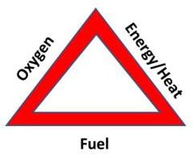

FIGURE 4.1: FIRE TRIANGLE

# CHAPTER 5

# COMPONENTS OF AN ELECTRICAL SUBSTATION

## LIGHTNING ARRESTERS

A lightning Arrester (also known as surge diverter or surge arrester) is device connected between line and earth, i.e., in parallel with the equipment to be protected at the substation. It is a safety valve which limits the magnitude of lightning and switching over voltages at the substation and provides a low resistance path for the surge current to flow to the ground. It is installed adjacent to the equipment to be protected.

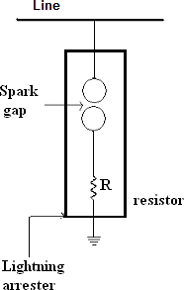

FIGURE 5.1 LIGHTNING ARRESTORS

## WAVE-TRAPPER

The wave-trapper is located on incoming lines to trap the high-frequency signal. This signal (wave) comes from the remote station which interrupts the current and voltage signals. This component trips the high-frequency signal and redirects them to the telecom board.

## CURRENT TRANSFORMER

A current transformer is an electrical device, and the main function of this is to change the value of current from a superior value to the minor value. This type of transformer is applicable in meters, control apparatus and parallel by AC instruments.

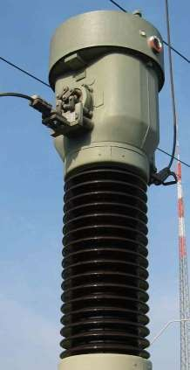

FIGURE 5.2: CURRENT TRANSFORMER

## GROUP OPERATING SYSYTEM or ISOLATORS

Isolators are used to make or break the circuit in no load conditions. The isolator is one type of [electrical switch,](https://www.elprocus.com/switches-types-working/) used to isolate the circuit whenever the flow of current has been disrupted. These switches are named as disconnected switches, and it works under a no-load condition. Isolators are not inbuilt by arc-quenching apparatus, and they don’t have any particular current- making or current-breaking capacity. In some situations, it is used to break the current charging of the line of transmission.

## CIRCUIT-BREAKER

This is a type of electrical switch, used to open or close the circuit when an error arises in the system. It includes two moving parts that are usually closed. When an error happens in the

system, then the relay transmits the signal to [the circuit-breaker](https://www.elprocus.com/types-of-circuit-breakers-and-its-application/) & therefore their parts are moved separately. Therefore, errors occur in the system turns into clear.

The types of Circuit Breaker’s are

* + 1. Oil Circuit Breaker (OCB)
    2. Vacuum Circuit Breaker (VCB)
    3. SF6 Circuit Breaker (SF6CB)
    4. Air Blast Circuit Breaker (ABCB)

## POTENTIAL TRANSFORMER

Potential and voltage transformer are the same. It's intended for both measurement and protection purposes. It's normally interposed between high tension power/transmission lines and control/measurement lines which are handled at safe/comfortable voltage levels (common standard being 110 V). Other than at LV distribution level of 240/415V, higher voltages may extend up to 100's of KV. Neither these potential levels are uniform in magnitude or feasible to access/handle directly. Hence the need to standardise a representative voltage — at 110 V (220V may be needed in some applications). They turn out to be of step down version in voltages. With the main requirement of accurate step down of voltage, secondary side can be calibrated and used as good as primary itself.

## BUS BAR

Busbar is a metallic strip or bar which is made up of copper, brass, aluminium that conducts electricity within switchboard, distribution board, substation, battery bank or other electrical apparatus. Its main purpose is to conduct a substantial current of electricity, enclosures for high current power didribution.

Busbars are made up of copper rod operated at constant voltage. In lager station it is important that breaker downs and maintenance should interfere as little as possible with continuity of supply to achieve this, duplicate bus bar system is used. Such a system consists of two bus bars, main bus bar and spare busbar with the help of bus coupler, which consist of the circuit breaker and isolator. In substation, it is often desire to disconnect a part of the system for general maintenance and repair.

## BATTERIES

In large power stations or substations, the operation of lighting, relay system, or control circuits are powered by batteries. These batteries are connected to a particular accumulator cell based on the operating voltage of the particular DC circuit.

The batteries are classified into two types namely acid-alkaline as well as lead acid. Lead acid batteries are applicable for substations, power stations due to their high voltage & very economical low voltage.

## SWITCHYARD

The switchyard is the inter-connector among the transmission as well as generation, & equal voltage is maintained in this device. Switchyards are used to transmit the power which is generated from the substation at the preferred level of voltage to the near transmission line or power station.

## RELAY

The relay is an electrical device, and the main role of this device in the substation is, it guards the grid component against the irregular conditions like faults. This is one type of detecting device, used to detect and determine the fault location, and then it sends the signal to the circuit breaker. After receiving the signal from [the relay,](https://www.elprocus.com/how-relays-work/) the circuit breaker will detach the faulted part. Relays are mainly useful for protecting the devices from hazards, damages.

## CAPACITOR BANK

This device is inbuilt with capacitors that are connected either in series or else parallel. The main function of this is to store the electrical energy in electrical charge form. This bank draws primary current which amplifies the PF (power factor) of the system. As a source, the capacitor bank works for reactive-power, and the phase-difference among the current as well as the voltage will be decreased. They will enhance the capacity of ripple current of the power supply, and it removes the unnecessary characteristics within the system. The capacitor bank is an efficient method for preserving [power factor](https://www.elprocus.com/power-factor-calculation/) as well as power-lag problem correction.

## TRANSFORMER

A transformer is a device that transfers electrical energy from one circuit to another through a shared magnetic field. A changing current in the first circuit (the primary) creates a changing magnetic field; in turn, this magnetic field induces a voltage in the second circuit (the secondary).

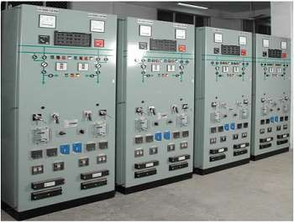

FIGURE 5.3: RELAYS

# CHAPTER 6

**TRANSFORMER LINE**

## INTRODUCTION

A transformer is a device that transfers electrical energy from one circuit to another through a shared magnetic field. A changing current in the first circuit (the primary) creates a changing magnetic field; in turn, this magnetic field induces a voltage in the second circuit (the secondary). By adding a load to the secondary circuit, one can make current flow in the transformer, thus transferring energy from one circuit to the other. The secondary induced voltage VS is scaled from the primary VP by a factor ideally equal to the ratio of the number of turns of wire in their respective windings:

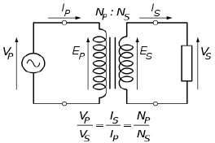

FIGURE 6.1: TRANSFORMER

By appropriate selection of the numbers of turns, a transformer thus allows an alternating Voltage to be stepped up — by making NS more than NP — or stepped down, by making it less Application of transformer is to reduce the current before transmitting electrical energy Over long distances through wires. By transforming electrical power to a high current from for transmission and back again afterwards the transformer allows electricity to be more effectively, enabling the economic transmission over long distance. Consequently, transformers have shaped the electricity supply industry, permitting generation to be located remotely from points of demand. All but a fraction of the world's electrical power has passed through a series of transformers by the time it reaches the consumer

## BASIC PRINCIPLE

The transformer is based on two principles: first, that an electric current can produce a magnetic field (electromagnetism) and, second, that a changing magnetic field within a coil of wire induces a voltage across the ends of the coil (electromagnetic induction). By changing the current in the primary coil, one changes the strength of its magnetic field; since the secondary coil is wrapped around the same magnetic field; a voltage is induced across the secondary a simplified transformer design is shown in Figure. A current passing through the primary coil creates a magnetic field. The primary and secondary coils are wrapped around a core of very high magnetic permeability, such as iron; this ensures that most of the magnetic field lines produced by the primary current are within the iron and pass through the secondary coil as well as the primary coil.

## DIFFERENT PARTS OF A TRANSFORMER

In a power transformer, these are the following main parts

* + 1. MAIN PARTS:
       1. Core
       2. Winding
       3. Tank cover
       4. Base channel
       5. L.V. & H.V. bushing
       6. Tap changer
       7. Conservator tank
       8. Earth terminals
       9. Rating plat
       10. Lifting lugs
    2. AUXILIARY PARTS
       1. Radiators
       2. Cooling fans
       3. Pressure Relief Valve\
       4. Breather
       5. Buchholz’s relay
       6. Drain valve
       7. Arching horns
       8. Oil level Indicator
       9. Oil Temperature Indicator
       10. Winding temperature Indicator

### CORE

* The magnetic core is three limbs or three limbs with two auxiliary limb types. Each limb being with top and bottom yokes. The lamination is made from high grade non aging cold rolled grain oriented silicon alloy steel. The insulation of lamination is carbide coating.
* The core has stepped core section. The gapes are clamped with end frames by yokes bolts or by fiber tube over clamped plates. For lighting the core with winding assembly. Four no. of lifting legs are provided on and frame cover.

### WINDINGS

Winding are arranged in concentric formation with lowest voltage winding next to the core in case, tertiary winding is arranged then this winding is placed next to the core over L.V. winding

* 1. winding and tapping are placed some time, tapping is placed after H.V. main winding depending upon requirement of impedance between various typed of winding used for making coil are as following:
     + Tertiary winding : Spiral/helied
     + Low winding : Helied/disc
     + High voltage winding : partially interlinked winding
     + Tapping winding: inter around spiral/helied coil.

### DRAIN VALUE

Drain Valve is used when we want to empty the transformer. With the help of drain valve we can release the total oil filled in the transformer.

### BUSHING

Bushings are of condenser type of protection depending upon the voltage class. Connection from the transformer winding is brought out by means of bushing ordinary protection bushing can be used up to 33Kv & above 33KV. Capacitor and oil fixed bushing is used. Bushings are fixed on the top of tank.

### AIR CELL

The air cell is the flexible rubber bag and is placed inside the conservator. It floats on the oil surface. The air cell inflates or deflates depending upon the expansion or contraction of oil. The dry air sucked into the cell doesn’t come in direct contact with oil, and then eliminates the probability of contamination.

### MAIN TANK

The tank is of welded mild steel plate construction sand/short blasted on inside and outside to remove scale formation. Tanks are designed to with stand a vacuum in line with CBIP recommended on transformer. The cover is either belt type of flat and remains mounted on the top of the tank rim. In tank insulating oil is fitted and it provides

### TAP CHANGER

Adjustment of voltage is done by changing the effective turn’s ratio of the system transformer by proper selections of tapping of the winding.

There are two types of tap changing:

* + - 1. Off load tap changing.
      2. On load tap changing.

In first form as the name implies it is essential to switch off the transformer before changing the tap. On load tap changers are employed to regulate voltage while transformer is delivering normal load.

Tap changer is provided on the outer winding or H.V. more ever the HV side as more no. of turns during transition, to adjacent taps are moment ably connected and the short circuit current is limited by automatic insertion of impedance in between the corresponding tapping other end.

A value is fitted at the lowest point of the tap for draining and sampling of oil. On the feed pipe buchholz’s relay is mounted.

### ARCHING HORNS

Arching horns protects a transformer over voltage faults. Whenever the voltage exceeds from its rated voltage. Supplying from generating station, this high voltage comes from generating station, this voltage comes on the arching horns and thus there is a sparking between the providing safety to the transformer from over voltage. Arching horns are mounted on the transformer bushing on every bushing there is a couple of arching horns, one is on upper side of the bushing and the second one is

on lower side. The distance of two horns are being standardizing as per rule for various voltages.

### OIL TEMPERATURE INDICATOR

This desistance thermometer operating on the principle of liquid expansion. It provides local indication of the top of the oil temperature at them marshalling box. The connection between thermometer bulb and the dial indicator is made by flexible steel capillary tube is enclosed in a pocket and the pocket is fixed on the transformer at the hottest oil region. The pocket has to be filled with transformer the oil temperature is provided with a maximum pointer and the two mercury switches one for alarm and other for trip. Switches are adjustable to make contact between 50˚C and 120˚C.

### OIL LEVEL INDICATOR

This indicator shows the level of oil filled in transformer. It is attached with conservator tank.

### WINDING TEMPERATURE INDICATOR

This indicator operating on the principle of liquid expansion provides local indications at the marshalling box of hot spot temperature of windings. The winding hot spot to top oil temperature differential is simulated by means of CT current fed to a coil around the operating bellows. Thus winding temperature indicates tem reading are proposal to load current pulse top oil tem the indicator is heated with maximum pointer and for mercury switch.

### CONSERVATOR TANK:

As the temperature of oil increase or decrease during operation there is corresponding rise or fall in the volume of oil. The account for this and It is a gas and oil actuated protection and is used practically In all oil immersed transformer with the exception of smaller distribution transformer. The device relies on the fact then an electric fault is side the transformer tank is accomplished by generation of gas and if the fault current is high enough by a surge of oil form the tank to conservator. The buchholz’s relay is particularly useful in that, it is capable of detection fault conditions of vary low magnitude such as internal fault, incipient winding fault and core faults. The use of buchholz’s relay is possible only with transformer having conservator and the relay is placed between transformer tank and the conservator tank.

### BREATHER

When the transformer is loaded or unloaded the oil temperature inside the transformer tank ruses of falls. Accordingly the air volume inside the tank changes by either sucking in or pushing out the air. This phenomenon is called Breathing of the transformer. The air, which is sucked in, contents either foreign Impurities and or humidity, which change dielectric strength of transformer oil. Hence it is necessary that the air entering into the transformer is free from moisture and foreign impurities.

### BUCHHOLZ’S REALAY

* The transformer if fitted double float Buchholz’s relay. It is fitted in the feed pipe from conservator to tank and is provided with two set of mercury contacts (Connected between main tank and conservator tank). The devices comprises of cast iron housing containing the hinged floats. One is upper part and other part is lower part. Each float is fitted with a mercury switch, which are connected to a terminal box. This alarm detects minor or major faults in transformer. The alarm element with operates after a specified volume of gas has collected to five an indication. Such faults are:

1. Broken drown core-bolt insulation
2. Sorted lamination
3. Bad contacts
4. Over heating of part of winding

* The alarm element will also operates in the even of the coil leakage or if air gets into the oil system the trip element will be operated by an oil surge in the event of more serious faults such as:-

1. Earth fault
2. Winding short circuit
3. Puncture of Bushing
4. Short circuit between phases.

The trip element will also be operated if a rapid loss.

### PRESSURE RELIVE VALVE

* The pressure relief valve is designed to use on power transformer. When pressure in the tank rises above predetermined safe limit this valve operates and perform following functions:-

1. Allow the pressure to the drop by instantaneously opening a part of about 150 mm
2. Given valve operating by rising a flog.
3. Operates a micro switch.

* This pressure relief valve has integral flange with six halves for mounting. The valve can be mounted vertically and horizontally on tank. The PRV has got a part of about 150 mm diameter.
* A stainless steel diaphragm seals this part. Whenever the pressure in the tank rises above pre- determined stage limit the diaphragm gets lifted from its seal this lifting in instantaneous and allow vapours gases or liquid to come out of tank depending upon the position of valve on tank. The diaphragm restores its position as soon as pressure in the tank drops below set limit.

### EARTHING ARRANG EMENTS

* Core earthling connecting leads from core and end frame are being laminated at the top of cover. By connecting those to tank cover core and core frame are earthed.
* Tank to tank cover earthling: - It is done by connecting copper straps between tank rim And tank cover.
* Earthling of Tank: - For farthing of tank, to earthing pads have been provided on tank.

# CHAPTER 7

**PROTECTIVE EARTHING**

# AND TRANSFORMER PROTECTION

## PROTECTIVE EARTHING

Earthing is a general term broadly representing grounding of power systems and bonding of equipment bodies to grounded electrodes. Earthing associated with current carrying power conductors, usually neutral conductor, is normally essential for the stability of the system and is generally known as system earthing. Earthing of non-current carrying metal works of equipment bodies is essential for the safety of life and property and is generally known as safety equipment earthing. The basic requirements of any earthing system are

* It should consist of equipotential bonding conductors capable of carrying the prospective earth fault current and a group of pipe/rod/plate earth electrodes for dissipating the current to the general mass of the earth without exceeding the allowable temperature limits in order to maintain all non-current carrying metal works reasonably at earth potential and to avoid dangerous contact potentials being developed on such metal works.
* It should limit earth resistance sufficiently low to permit adequate fault current for the operation of protective device in time and reduce shifting.
* (iii) It should be mechanically strong, withstand corrosion and retain electrical continuity during the life of the installation. Earth electrodes, which form part of the earthing system, are provided to dissipate fault current during earth fault and to maintain the earth resistance to a reasonable value so as to avoid rise of potential of the earthing grid. The resistance to earth of an electrode of given dimensions is dependent on the electrical resistivity of the soil in which it is installed. In addition to the measurement of soil resistivity at the design stage, it is essential to repeat the measurement at the pre-commission stage also, as the effectiveness of the earthing system depends on the value of soil resistivity . Hence before energising electric supply lines and apparatus it is necessary that all components of the earthing system including the soil are inspected and tested to ensure efficient functioning of the system.

## TRASFORMER PROTECTION

If the electric transmission and distribution system is like a human body, then a transformer is as a backbone in human body. So protection for a transformer is much necessary.

The following protections are provided to power transformer mounted at GSS:-

1. Over current protection
2. Differential protection
3. Over pressure protection
4. Temperature over rise protection
5. Earth fault protection
6. Buchholz’s protection
7. Winding temperature rise protection
8. Oil temperature rise protection
9. Over voltage protection
10. Impedance or Distance protection

### OVER CURRENT PROTECTION

When as the load increases on the transformer, current taken by transformer also increases in steps. In this situation transformer is said to be in over current position and if this position is maintained for a long period, then there can be dangerous hazard to transformer and obviously there can be damage to line. So to protect transformer from over current, there is a relay called (over current relay) is connected to the transformer, which operates when the transformer gets in the control panel and automatically the circuit breaker opens and cut-off the transformer from mains. The relay is energized by 220V DC coming from battery room.

### DIFFERENTIAL PROTECTION

The operation of relay is depends on the difference in magnitude or phase of current or voltage. For the purpose two current transformers are used at both ends of the system to be protected

.These transformer have same ratio of transformation and their secondary are interconnected.

For this protection there is also a relay used which is connected in for the feeder between the substations. Whenever there is a difference in the magnitude of transformer. relay operates and gives a signal to the C.B. to be operated, providing protection to the transformer.

### OVER PRESSURE PROTECTION

When we know that a transformer is filled up with transformer oil, then oil is filled in a particular pressure, when as there is any heating in winding or oil, gas formation develops which increase the pressure in the tank. Tank is made for definite pressure to be tolerated. If the pressure increase from this definite value, there can be a danger to transformer from over pressure situation there is a pressure relief value operates or opens providing free exist of a formatted gases so that the over pressure can be converted into normal pressure and escape the tank from over pressure.

### TEMPERATURE OVER RISE PROTECTION

This type of protection protests the transformer from the over heating of transformer winding and oil. So this protection as called over temperature rise protection. As the current flows through the winding, there is I²R losses takes place in winding resulting in the heating of winding .whenever the transformer is over loaded over heating of transformer oil and winding. If this over heating will not be compensated by any source then there can be burning of winding or failure of the insulation. If the insulation of winding fails then may be short circulating between winding turns. So to protect the transformer and to compensate the overheating , the cooling is used.

**COOLING OF TRANSFORMER:** Due to internal heating in the winding of a transformer, cooling is a necessary part of any power transformer.

There are three type of cooling:

* + - 1. ONAN (Oil Natural Air Natural)
      2. ONAF (Oil Natural Air Forced)
      3. OFAF (Oil Forced Air Forced)

### EARTH FAULT PROTECTION

When from any reason, the winding insulation or conductor insulation breaks down, the base conductor touches metallic part and spreading current in whole of metallic body. If any body touches in these condition, then there may be a great a great electric shock to human body. Difference between phase and earth becomes zero.

### BUCHHOLZ’S PROTECTION

It is a gas and oil actuated protection and is used practically In all oil immersed transformer with the exception of smaller distribution transformer. The device relies on the fact then an electric fault is side the transformer tank is accomplished by generation of gas and if the fault current is high enough by a surge of oil form the tank to conservator. The buchholz’s relay is particularly useful in that, it is capable of detection fault conditions of vary low magnitude such as internal fault, incipient winding fault and core faults. The use of buchholz’s relay is possible only with transformer having conservator and the relay is placed between transformer tank and the conservator tank.

### WINDING TEMPERATURE RISE PROTECTION

Whenever the temperature of the winding increases more than sufficient then the winding temperature indicator gives signal for that and the alarm warm us about the rise in winding temperature. Then we can easily make the suitable arrangement to protect the transformer.

### OIL TEMPERATURE RISE PROTECTION

We use an Oil Temperature Indicator whose work is to keep a watch on the temperature of the transformer oil. In case of any unwanted rise in the temperature of oil the Oil Temperature Indicator provides a signal and the alarm warm us about the temperature rise in transformer oil.

### OVER VOLTAGE PROTECTION

Due to any over voltages the transformer winding can be damaged therefore it is very necessary for us to avoid such conditions. Thus to prevent this we uses Over Voltage Protection.

### IMPEDENCE OR DISTANCE PROTECTION

Distance protection is a resistance depends time graded protection. The operation time of which is determine by the distance to the faults. This protection is used for transformer lines. It is a new unit type protection and high speed protection and simply to apply. It can be used as a primary and backup protection.

# CHAPTER 8

**PROTECTIVE RELAYS**

## PROTECTIVE RELAY

Protective relays are used to detect defective lines or apparatus and to initiate the operation of circuit interrupting devices to isolate the defective equipment. Relays are also used to detect abnormal or undesirable operating conditions other than those caused by defective equipment and either operates an alarm or initiate operation of circuit interrupting devices. Protective relays protect the electrical system by causing the defective apparatus or lines to be disconnected to minimize damage and maintain service continuity to the rest of the system.

There are different types of relays:

1. Over current relay
2. Distance relay
3. Differential relay
4. Directional over current relay

### OVER CURRENT RELAY

* The over current relay responds to a magnitude of current above a specified value. There are four basic types of construction: They are plunger, rotating disc, static, and microprocessor type. In the plunger type, a plunger is moved by magnetic attraction when the current exceeds a specified value. In the rotating induction-disc type, which is a motor, the disc rotates by electromagnetic induction when the current exceeds a specified value.
* Microprocessor relays convert the current to a digital signal. The digital signal can then be compared to the setting values input into the relay. With the microprocessor relay, various curves or multiple time-delay settings can be input to set the relay operation. Some relays allow the user to define the curve with points or calculations to determine the output characteristics.

### DISTANCE RELAY

* The Distance Relays as the overall effect of measuring impedance. The relay operates instantaneously (with in a few cycles) on a 60-cycle basis for values of iropedance below the set

value. When time delay is required, the relays energizes a separate time-delay function with the contacts or output of this time- delay relay or function performing the desired output functions.

* The relay operates on the magnitude of impedance measured by the combination of restraint voltage and the operating current passing through it according to the settings applied to the relay. When the impedance is such that the impedance point is within the impedance characteristic circle, the relay will trip. The relay is inherently directional. The line impedance typically corresponds to the diameter of the circle with the reach of the relay being the diameter of the circle.

### DIFFERENTIAL RELAY

* The differential relay is a current-operated relay that responds to the difference between two or more device currents above a set value. The relay works on the basis of the differential principle that what goes into the device has to come out. If the current does not add to zero, the error current flows to cause the relay to operate and trip the circuit.
* The differential relay is used to provide internal fault protection to equipment such as transformers, generators, and buses. Relays are designed to permit differences in the input currents as a result of current transformer mismatch and applications where the input currents come from different system voltages, such as transformers a current differential relay provides restraint coils on the incoming current circuits. The restraint coils in combination with the operating coil provide an operation curve, above which the relay will operate.
* Differential relays are often used with a lockout relay to trip all power sources to the device and prevent the device from being automatically or remotely reenergized. These relays are very sensitive. The operation of the device usually means major problems with the protected equipment and the likely failure in re-energizing the equipment.

### DIRECTION OVER CURRENT RELAY

* A directional over current relay operates only for excessive current flow in a given direction Directional over current relays are available in electromechanical, static, and microprocessor constructions.
* An electromechanical overcorrect relay is made directional by adding a directional unit that prevents the over current relay from operating until the directional unit has operated.
* The directional unit responds to the product of the magnitude of current, voltage, and the phase angle between them or to the product of two currents and the phase angle between them. The value of this product necessary to provide operation of the directional unit is small, so that it will not limit the sensitivity of the relay (such as an over current relay that it controls). In most cases, the directional element is mounted inside the same case as the relay it controls. For example, an over current relay and an element are mounted in the same case, and the combination is called a directional over current relay. Microprocessor relays often provide a choice as to the polarizing method that can be used in providing the direction of fault, such as applying residual current or voltage or negative sequence current or voltage polarizing functions to the relay.

# CHAPTER 9

**220/66/11 KV RECIVING SUBSTATION, VAJAMANGALA, KPTCL, MYSURU**

## SINGLE LINE DIAGRAM

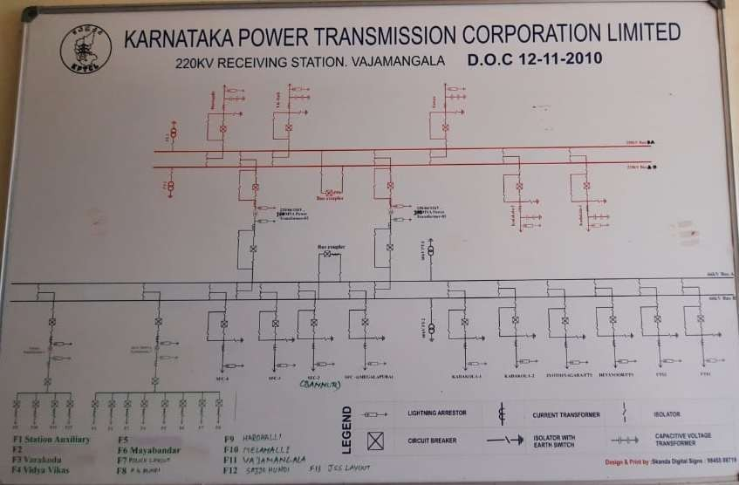

FIGURE 7.1: SINGLE LINE DIAGRAM OF 220KV RECIVING SUBSTATION

* + - This substation has the capacity of 220KV and can step down to 66kv and 11kv using input lines through the incoming feeders.
    - The input feeders are namely,

1. Hootagally
2. T K Halli

These feeders come into the substation with 220KV

* + - The substation of 220KV/66KV has 10 outgoing feeders,namely:

1. SFC-4
2. SFC-3
3. SFC-2(BANNUR)
4. SFC-1(MEGALAPURA)
5. KADAKOLA-1
6. KADAKOLA-2
7. JYOTHINAGARA
8. DEVANOORU
9. FTS1
10. FTS2

These feeders come into the substation with 66KV

* + - The substation 66 KV /11 KV has 13 outgoing feeders,namely:

1. F1-Stationary Auxiliary
2. F2
3. F3-Varakoda
4. F4-Vidya Vikas
5. F5
6. F6-Mayabandar
7. F7-Police Layout
8. F8-K G Hundi
9. F9-Horohalli
10. F10-Mellahalli
11. F11-Vajamanagala
12. F12-Sajje Hundi
13. F13-JSS Layout
    * + Transformer Rating :
14. Transformer 1: 220/66/11KV, 100 MVA Power(Star, Delta, Star Auto)
15. Transformer 2: 220/66/11KV, 100 MVA Power(Star, Delta, Star Auto)
16. Transformer 3: 66/11 KV , 20 MVA Power (Star Delta Connection)

## 220 KV SUBSTATION

220KV Sub-Station forms an important link between Transmission network and Distribution Network. It has a vital influence of reliability of service. Apart from ensuring efficient Transmission and Distribution of power, the sub-station configuration should be such that it enables easy maintenance of equipment and minimum at erruptions in power supply. A Sub- Station Is constructed near as possible to the load center. The voltage level of power transmission is decided on the quantum of power to be transmitted to the load centre.

## 220KV SUBSTATION COMPONENTS

* + - Bus-bar
    - Insulators
    - Isolating Switches
    - Circuit breaker
    - Protective relay
    - Instrument Transformer
    - Current Transformer
    - Voltage Transformer
    - Metering and Indicating Instrument
    - Miscellaneous equipment
    - Transformer
    - Lightning arrestors
    - Line isolator
    - Wave trap

### BATTERY ROOM:

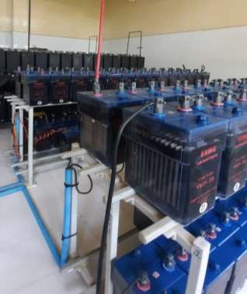

FIGURE 7.2: BATTERY ROOM

# CHAPTER 10

**66/11 KV MUSS GIS, KALAMANDIR KPTCL, MYSURU**

## INTRODUCTION OF GIS

* Gas Insulated Substations are high voltage Substations that are compact, requiring little maintenance when compared to air-insulated conventional Substations. Compressed Gas Insulated Substations (CGIS) consist basically a conductor supported on insulators inside an enclosure which is filled with sulfur hexafluoride gas (SF6). The compactness is with the use of SF6 gas, which has high dielectric strength. The voltage withstand capability of SF6 Busduct is strongly dependent on field perturbations, such as those caused by conductor surface imperfections and by conducting particle contaminants. The contaminants can be produced by abrasion between components during assembly or operations.
* Electrical insulation performance of compressed gas insulated Substation is adversely affected by metallic particle contaminants. Free conducting particles, depending upon their shape, size and location, may lead to serious deterioration of the dielectric strength of the system and also one of the major factors causing breakdown of the system and leading to power disruption. These particles can either be free to move in the Gas Insulated Busduct (GIB) or they may be stuck either to an energized electrode or to an enclosure surface. The presence of contamination can therefore be a problem with gas insulated substations operating at high fields.
* If a metallic particle crosses the gap and comes into contact with the inner electrode or if a metallic particle adheres to the inner conductor, the particle will act as a protrusion on the surface of the ii electrode.
* Consequently, voltage required for breakdown of the GIS will be significantly decreased. Several methods have been used to reduce the effect of conducting particles, including electrostatic trapping, use of adhesive coatings, and discharging of conducting particles through radiation. Dielectric coating of a metallic electrode surface affects the particle charge mechanism.

## COMPPONENTS OF GIS

Gas Insulated Substations (GIS) is a compact, multicomponent assembly enclosed in a ground metallic housing which the primary insulating medium is compressed sulphur hexafluoride (SF6) gas.

GIS generally consists components of:

* + 1. Circuit Breakers
    2. Operating mechanism of circuit breaker
    3. Current transformers
    4. Disconnector
    5. Maintenance Earthing switches
    6. Fast acting Earthing switches
    7. Voltage transformers
    8. SF6 Bushing
    9. Gas supply and gas monitoring equipment
    10. Bus Bar
    11. Voltage Transformer
    12. Gas supply and Monitoring equipment

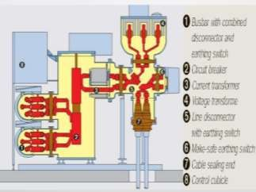

FIGURE 10.1 GIS COMPONENTS

## WHY WE NEED GIS:

* Gas Insulated Substations are used where there is space for providing the substation is expensive in large cities and towns. In normal substation the clearances between the phase to phase and

phase to ground is very large. Due to this, large space is required for the normal or Air Insulated Substation (AIS). But the dielectric strength of SF6 gas is higher compared to the air, the clearances required for phase to phase and phase to ground for all equipments are quite lower. Hence, the overall size of each equipment and the complete substation is reduced to about 10% of the conventional air insulated substation.

* Extremely high dielectric properties of SF6 have long been recognized. Compressed SF6 has been used as an insulating medium as well as arc quenching medium in electrical apparatus in a wide range of voltages.
* Gas Insulated Substations (GIS) can be used for longer times without any periodical inspections. Conducting contamination (i.e. aluminum, copper and silver particles) could, however, seriously reduce the dielectric strength of gas-insulated system. A metallic particle stuck on an insulator surface in a GIS will also cause a significant reduction of the breakdown voltage.
* Gas insulated Substations have found a broad range applications in power systems over the last three decades because of their high reliability Easy maintenance, small ground space requirements etc... Because of the entire equipment being enclosed in enclosures, filled with pressurized SF6 gas, installation is not subject to environmental pollutions, as experienced along coastal areas or certain types of industries.
* Such installations are preferred in cosmopolitan cities, industrial townships, etc., where cost of land is very high and higher cost of SF6 insulated switchgear is justified by saving due to reduction in floor area requirement. It is not necessary that high voltage or extra high voltage switchgear to be installed out doors.
* Since most of the construction is modular and the assembly is done in the works, one site erection time both for supporting structures and switchgear is greatly reduced.

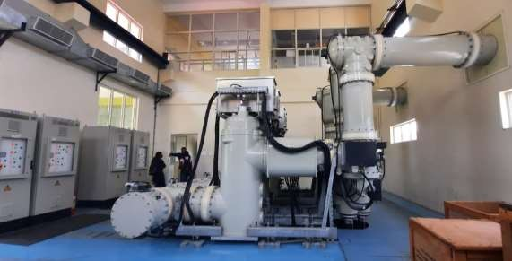

FIGURE 10.2 GAS INSULATED SUBSTATION

## SINGLE LINE DIAGRAM

* This substation has the capacity of 66 KV and can step down to 11kv using input lines through the incoming feeders.
* The input feeders are namely,

1. Bogadi
2. Mysuru South

These feeders come into the substation with 66 KV

* The substation 11 KV has 11 outgoing feeders,namely:

1. Idle Feeder
2. Kukkarahalli
3. Bahaddur
4. Chumundeshwari
5. Meteroplole
6. University
7. Court
8. CFTRI
9. Urs Road
10. Padavarahalli
11. Idle Feeder
12. Station Transformer Rating :
13. Transformer 1: 66/11KV, 12.5 MVA Power
14. Transformer 2: 66/11KV, 12.5 MVA Power

# CHAPTER 11

**66/11 KVASUBSTATION,DATAGALLY KPTCL, MYSURU**

## SINGLE LINE DIAGRAM

**:**

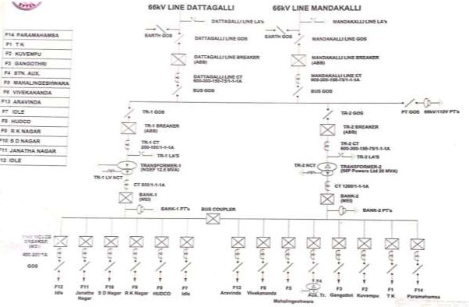

FIGURE 11.1:66/11 KVA SUBSTATION

* + - This substation has the capacity of 66 KV and can step down to 11kv using input lines through the incoming feeders.
    - The input feeders are namely,

1. Dattagalli
2. Mandakalli

These feeders come into the substation with 66 KV

* + - The substation 11 KV has 13 outgoing feeders, namely:

1. Idle Feeder
2. Jnatha Nagar
3. S D Nagar
4. R K Nagra
5. HUDCO
6. Idle Feeder
7. Arvinda
8. Vivekananda
9. Mahalingeshwara
10. AUX
11. Gangothri
12. Kuvempu
13. T K Layout
14. Paramahamsa Transformer Rating:
15. Transformer 1: 66/11KV, 12.5 MVA Power
16. Transformer 2: 66/11KV, 20. MVA Power

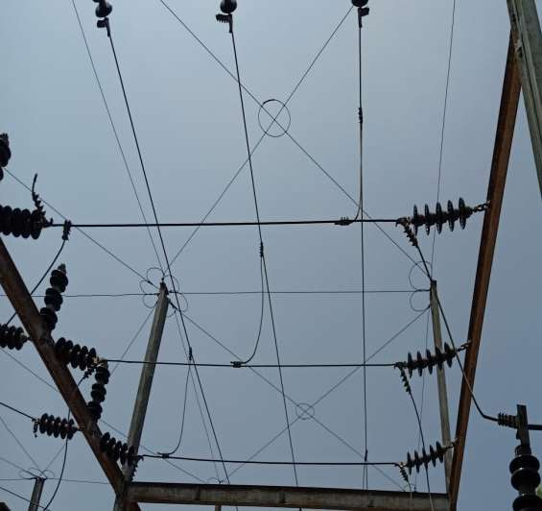

FIGURE 11.2: Faraday Cage

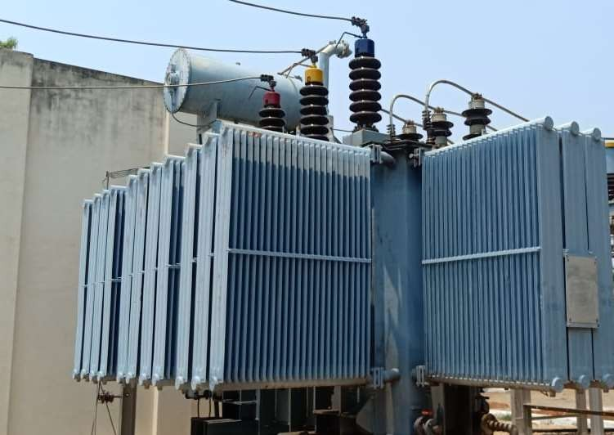

FIGURE 11.4: TRANSFORMER WITH RADIATORS

# CHAPTER 12

**CONCLUSION**

Now from this report we can conclude that centricity plays an important role in our lie. We are made aware of how the transmission the transmission of electricity is done. We too came to know about the various parts of the substation system. The three wings of electrical system viz.generation transmission and distribution are connected to each other and that to very perfectly.

Thus for effective transmission and distribution a substation must:

* Ensure steady state and stability
* Effective voltage control
* Prevention of loss of synchronism
* Reliable supply by feeding the network at various points
* Fault analysis improvement in respective field
* Establishment of economic load distribution

GIS are necessary for EHV&UHV and some important areas to be studied include more conservative designs better particle control improved gas handling decomposition product management techniques Achieving maintaining high levels of availability requires a more integrated approach to quality control by both users and manufactures